Economics: Canada in the Global Environment, 7e (Parkin)
Chapter 16 Externalities

16.1 Externalities in Our Lives

1) An externality is defined as
A) an additional cost imposed by the government on producers.
B) an additional gain received by consumers from decisions made by the government.
C) a cost or benefit that arises from production and falls on someone other than the producer, or a cost or benefit that arises from consumption and falls on someone other than the consumer.
D) a marginal social cost.
E) the additional amount consumers have to pay to consume an additional amount of a good or service.
Answer: C
Diff: 1
Topic: Externalities in Our Lives

2) An externality is a cost or benefit arising from an economic activity that falls on
A) consumers but not producers.
B) producers but not consumers.
C) consumers or producers.
D) someone other than consumers or producers.
E) none of the above.
Answer: D
Diff: 2
Topic: Externalities in Our Lives
Source: Study Guide

3) Which of the following illustrates the concept of external cost?
A) Bad weather reduces the size of the wheat crop.
B) A reduction in the size of the wheat crop causes income of wheat farmers to fall.
C) Smoking harms the health of the smoker.
D) Smoking harms the health of nearby nonsmokers.
E) Public health services reduce the transmission of disease.
Answer: D
Diff: 2
Topic: Externalities in Our Lives
Source: Study Guide

4) Air pollution generated by a paper mill factory is an example of a
A) positive production externality.
B) positive consumption externality.
C) negative consumption externality.
D) marginal external benefit.
E) negative production externality.
Answer: E
Diff: 1
Topic: Externalities in Our Lives
5) Sixty percent of our air pollution comes from
A) solid waste disposal.
B) electric utilities.
C) a growing world population.
D) road transportation and industrial processes .
E) none of the above.
Answer: D
Diff: 1
Topic: Externalities in Our Lives

6) A well-maintained water-front property that is enjoyed by other property owners is an example of
A) an inefficient allocation of resources.
B) a negative consumption externality.
C) a positive consumption externality.
D) a negative production externality.
E) a positive production externality.
Answer: C
Diff: 2
Topic: Externalities in Our Lives

7) An example of an activity that creates a negative consumption externality is
A) logging, which pollutes rivers.
B) locating beehives next to an orange orchard.
C) smoking, which harms the health of a bystander.
D) a flu vaccination.
E) none of the above.
Answer: C
Topic: Externalities in Our Lives
Skill: Conceptual
AACSB: Reflective Thinking

8) Smoking tobacco creates a ________ externality.
A) negative consumption
B) negative production
C) positive consumption
D) positive production
E) none of the above
Answer: A
Diff: 1
Topic: Externalities in Our Lives
Skill: Conceptual
AACSB: Reflective Thinking
9) An example of an activity that creates a positive consumption externality is
A) logging, which pollutes rivers.
B) locating beehives next to an orange orchard.
C) smoking, which harms the health of a bystander.
D) a flu vaccination.
E) a noisy party.
Answer: D
Topic: Externalities in Our Lives
Skill: Conceptual
AACSB: Reflective Thinking

10) A homeowner planting an attractive garden in front of his house creates ________.
A bakery baking bread creates ________.
A) no externality; a positive production externality
B) a positive consumption externality; no externality
C) no externality; no externality
D) a positive consumption externality; a positive production externality
E) a positive production externality; no externality
Answer: D
Topic: Externalities in Our Lives
Source: MyEconLab
16.2 Negative Externalities: Pollution

Use the figure below to answer the following questions.

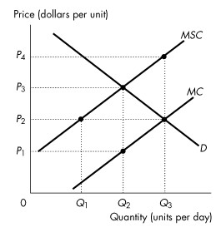
Figure 16.2.1

1) Refer to Figure 16.2.1. The figure shows the private marginal cost curve, the social marginal cost curve and the market demand curve. If the market is unregulated, then the quantity produced is
A) zero.
B) Q1.
C) Q2.
D) Q3.
E) too low.
Answer: D
Diff: 1
Topic: Negative Externalities: Pollution

2) Refer to Figure 16.2.1. The figure shows the private marginal cost curve, the social marginal cost curve and the market demand curve. If the market is unregulated, then the price is
A) P1.
B) P4.
C) below P1.
D) P2.
E) P3.
Answer: D
Diff: 1
Topic: Negative Externalities: Pollution
3) Refer to Figure 16.2.1. The figure shows the private marginal cost curve, the social marginal cost curve and the market demand curve. If the market is unregulated, then at the equilibrium output the marginal social cost of production is
A) less than the marginal benefit to consumers.
B) greater than the marginal benefit to consumers.
C) equal to the marginal benefit to consumers.
D) equal to the marginal private cost of production.
E) less than the marginal private cost of production.
Answer: B
Diff: 2
Topic: Negative Externalities: Pollution

4) Refer to Figure 16.2.1. The figure shows the private marginal cost curve, the social marginal cost curve and the market demand curve. If the market is unregulated, then
A) the quantity produced is efficient but price is too low.
B) the quantity produced is less than the efficient quantity.
C) the quantity produced is greater than the efficient quantity.
D) the quantity produced is efficient but the price is too high.
E) the externality is eliminated.
Answer: C
Diff: 2
Topic: Negative Externalities: Pollution

5) Refer to Figure16.2.1. The figure shows the private marginal cost curve, the social marginal cost curve and the market demand curve. To promote an efficient allocation of resources, the government could impose a constant per unit tax equal to
A) zero.
B) P1.
C) P3 - P1.
D) P4 - P1.
E) P3 - P2.
Answer: C
Diff: 2
Topic: Negative Externalities: Pollution

6) Refer to Figure 16.2.1. The figure shows the private marginal cost curve, the social marginal cost curve and the market demand curve. If a constant per unit tax is imposed that generates an efficient allocation of resources, then the quantity produced is
A) zero.
B) Q1.
C) Q2.
D) Q3.
E) greater than Q3.
Answer: C
Diff: 2
Topic: Negative Externalities: Pollution
7) Refer to Figure 16.2.1. The figure shows the private marginal cost curve, the social marginal cost curve and the market demand curve. If a constant per unit tax is imposed that generates an efficient allocation of resources, then consumers pay a per unit price of
A) zero.
B) P1.
C) P2.
D) P3.
E) P4.
Answer: D
Diff: 2
Topic: Negative Externalities: Pollution

8) Refer to Figure 16.2.1. The figure shows the private marginal cost curve, the social marginal cost curve and the market demand curve. If a constant per unit tax is imposed that generates an efficient allocation of resources, then producers receive a per unit price of
A) zero.
B) P4.
C) P3.
D) P2.
E) P1.
Answer: E
Diff: 2
Topic: Negative Externalities: Pollution

9) Effective strategies for addressing the problem of negative externalities include
A) taxing the profit of polluting companies at twice the rate of non-polluting companies.
B) imposing taxes on the activity that generates the pollution.
C) stressing the use of renewable resources.
D) imposing recycling laws.
E) closing down a polluting industry.
Answer: B
Diff: 2
Topic: Negative Externalities: Pollution
Use the table below to answer the following questions.

Table 16.2.1

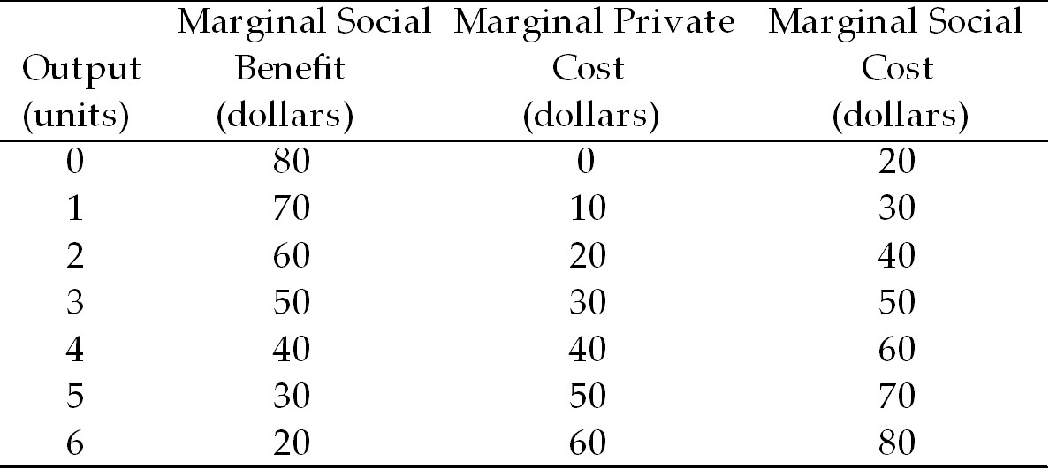

10) Refer to Table 16.2.1. Given in the table are the marginal private cost and the marginal social cost of the production of chemical fertilizer and the marginal social benefit from the consumption of fertilizer. Under these circumstances,
A) there are positive externalities in this market.
B) there are negative externalities in this market, equal to $10 per unit.
C) there are no externalities in this market.
D) not enough information is provided to determine whether or not there are externalities.
E) there are negative externalities in this market, equal to $20 per unit.
Answer: E
Diff: 2
Topic: Negative Externalities: Pollution

11) Refer to Table 16.2.1. Given in the table are the marginal private cost and the marginal social cost of the production of chemical fertilizer and the marginal social benefit from the consumption of fertilizer. If the market is unregulated, the quantity produced is
A) 1 unit.
B) 2 units.
C) 3 units.
D) 4 units.
E) 5 units.
Answer: D
Diff: 1
Topic: Negative Externalities: Pollution

12) Refer to Table 16.2.1. Given in the table are the marginal private cost and the marginal social cost of the production of chemical fertilizer and the marginal social benefit from the consumption of fertilizer. If the market is unregulated, the market price is
A) $10 a unit.
B) $20 a unit.
C) $30 a unit.
D) $40 a unit.
E) $50 a unit.
Answer: D
Diff: 1
Topic: Negative Externalities: Pollution
13) Refer to Table 16.2.1. Given in the table are the marginal private cost and the marginal social cost of the production of chemical fertilizer and the marginal social benefit from the consumption of fertilizer. Assume the market is perfectly competitive. If the market is unregulated, the marginal
A) social cost equals the marginal private benefit.
B) private cost is less than the marginal social benefit.
C) private cost equals the marginal social benefit.
D) social cost equals the marginal private cost.
E) private cost is greater than the marginal social benefit.
Answer: C
Diff: 2
Topic: Negative Externalities: Pollution

14) Refer to Table 16.2.1. Given in the table are the marginal private cost and the marginal social cost of the production of chemical fertilizer and the marginal social benefit from the consumptin of fertilizer. If the market is unregulated
A) the quantity produced is the efficient quantity.
B) the quantity produced is greater than the efficient quantity.
C) the quantity produced is less than the efficient quantity.
D) marginal external cost is maximized.
E) production is technologically inefficient.
Answer: B
Diff: 2
Topic: Negative Externalities: Pollution

15) Refer to Table 16.2.1. Given in the table are the marginal private cost and the marginal social cost of the production of chemical fertilizer and the marginal social benefit from the consumptin of fertilizer. If the government decides to correct the externality problem, it could
A) subsidize production by $20 per unit.
B) subsidize production by $10 per unit.
C) provide the good itself.
D) tax production by $10 per unit.
E) tax production by $20 per unit.
Answer: E
Diff: 3
Topic: Negative Externalities: Pollution
Use the figure below to answer the following questions.

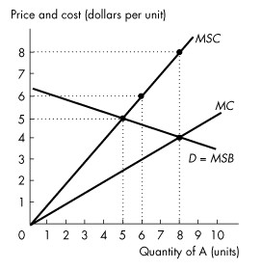
Figure 16.2.2

16) Refer to Figure 16.2.2. This figure shows the demand curve, the marginal private cost curve and the marginal social cost curve of good A. Production of the 6th unit of output generates a marginal external
A) cost of $1.50.
B) cost of $3.
C) cost of $6.
D) benefit of $3.
E) benefit of $6.
Answer: B
Diff: 2
Topic: Negative Externalities: Pollution
Source: Study Guide

17) Refer to Figure 16.2.2. This figure shows the demand curve, the marginal private cost curve and the marginal social cost curve of good A. How many units of good A are produced in an unregulated market?
A) 0 units
B) 5 units
C) 6 units
D) 8 units
E) 9 units
Answer: D
Diff: 1
Topic: Negative Externalities: Pollution
Source: Study Guide
18) Refer to Figure 16.2.2. This figure shows the demand curve, the marginal private cost curve and the marginal social cost curve of good A. What is the efficient quantity of good A?
A) 0 units
B) 5 units
C) 6 units
D) 8 units
E) impossible to determine without additional information
Answer: B
Diff: 1
Topic: Negative Externalities: Pollution
Source: Study Guide

19) Refer to Figure 16.2.2. This figure shows the demand curve, the marginal private cost curve and the marginal social cost curve of good A. If the government wanted to achieve the efficient quantity of good A, it could issue marketable permits. If the marketable permits result in the efficient quantity of good A, then the quantity of good A produced is
A) 0 units.
B) 5 units.
C) 6 units.
D) 8 units.
E) a level impossible to determine without more information.
Answer: B
Diff: 3
Topic: Negative Externalities: Pollution

20) In the absence of government intervention, a profit-maximizing firm producing a good with an external cost will produce a quantity at which
A) price is greater than marginal private cost.
B) price is less than marginal revenue.
C) price is less than marginal private cost.
D) price equals marginal private cost.
E) marginal revenue equals marginal social cost.
Answer: D
Diff: 2
Topic: Negative Externalities: Pollution

21) When an additional unit of output is produced, the extra cost to society is the
A) average total cost.
B) marginal social cost.
C) marginal private cost.
D) marginal external cost.
E) marginal damage.
Answer: B
Diff: 2
Topic: Negative Externalities: Pollution
22) Means of coping with negative externalities include all of the following except
A) emission charges.
B) patents.
C) property rights.
D) Pigovian taxes.
E) marketable permits.
Answer: B
Diff: 1
Topic: Negative Externalities: Pollution

23) Which one of the following is a means of coping with a negative externality?
A) emission subsidies
B) patents
C) vouchers
D) Pigovian taxes
E) copyrights
Answer: D
Diff: 1
Topic: Negative Externalities: Pollution

24) A battery acid producer pollutes the water upstream from the Polar Bear Club, a swimming club. If transactions costs are low, the quantity of pollution will be efficient
A) only if Ronald Coase is a member of the Polar Bear Club.
B) only if Ronald Coase is not a member of the Polar Bear Club.
C) only if water property rights are assigned to the producer.
D) only if water property rights are assigned to the Polar Bear Club.
E) if water property rights are assigned either to the producer or to the Polar Bear Club.
Answer: E
Diff: 3
Topic: Negative Externalities: Pollution
Source: Study Guide

25) The Coase theorem states that
A) patents and copyrights will solve the problem of external costs.
B) taxes will solve the problem of external costs.
C) global warming is hard to solve due to the prisoners' dilemma aspect of the problem.
D) property rights are social arrangements governing ownership, use and disposal of factors of production and goods and services.
E) if property rights are established, and if only a small number of parties are involved, and if transactions costs are low, then private transactions are efficient.
Answer: E
Diff: 2
Topic: Negative Externalities: Pollution
Use the table below to answer the following questions.

Table 16.2.2
Chemical Fertilizer Market

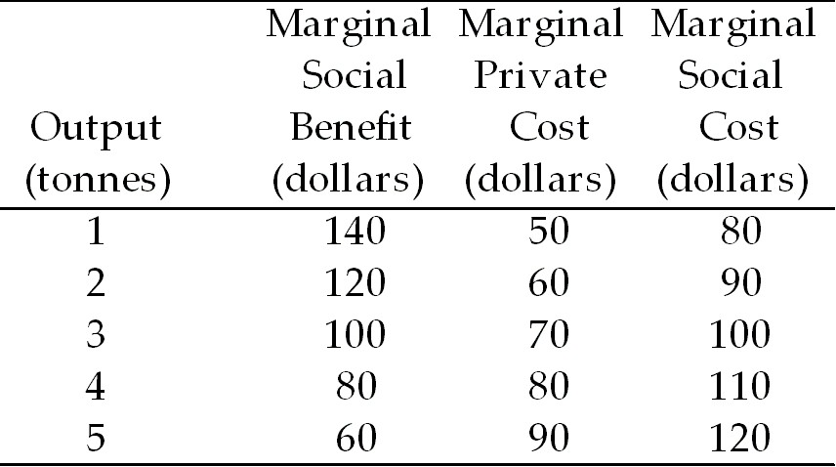

26) Refer to Table 16.2.2. If the fertilizer market is perfectly competitive and unregulated, output (in tonnes) is
A) 1.
B) 2.
C) 3.
D) 4.
E) 5.
Answer: D
Diff: 1
Topic: Negative Externalities: Pollution
Source: Study Guide

27) Refer to Table 16.2.2. Fertilizer has a marginal
A) external cost of $100 a tonne.
B) social cost of $100 a tonne.
C) external cost of $30 a tonne.
D) private cost of $30 a tonne.
E) external cost of $0.
Answer: C
Diff: 2
Topic: Negative Externalities: Pollution

28) Refer to Table 16.2.2. The efficient output of fertilizer is
A) 1 tonne.
B) 2 tonnes.
C) 3 tonnes.
D) 4 tonnes.
E) 5 tonnes.
Answer: C
Diff: 2
Topic: Negative Externalities: Pollution
Source: Study Guide
29) Refer to Table 16.2.2. The Pigovian tax that achieves the efficient quantity of output is
A) $0.
B) $10 a tonne.
C) $20 a tonne.
D) $30 a tonne.
E) $40 a tonne.
Answer: D
Diff: 2
Topic: Negative Externalities: Pollution

Use the figure below to answer the following questions.

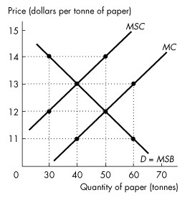
Figure 16.2.3

30) Refer to Figure 16.2.3. The unregulated outcome in the paper market is
A) a quantity of 40 tonnes and a price of $11 a tonne
B) a quantity of 40 tonnes and a price of $13 a tonne
C) a quantity of 50 tonnes and a price of $12 a tonne
D) a quantity of 50 tonnes and a price of $14 a tonne
E) a quantity of 60 tonnes and a price of $13 a tonne
Answer: C
Diff: 1
Topic: Negative Externalities: Pollution

31) Refer to Figure 16.2.3. In this market there is a marginal external
A) cost of $14 a tonne.
B) cost of $12 a tonne.
C) cost of $2 a tonne.
D) benefit of $2 a tonne.
E) benefit of $12 a tonne.
Answer: C
Diff: 2
Topic: Negative Externalities: Pollution
32) Refer to Figure 16.2.3. A tax of ________ per tonne is necessary to achieve the efficient output of ________ tonnes of paper.
A) $14; 50
B) $14; 30
C) $13; 40
D) $2; 50
E) $2; 40
Answer: E
Diff: 2
Topic: Negative Externalities: Pollution

33) If negative externalities exist, then in a market with no property rights,
A) MSC = MSB.
B) MSC < MSB.
C) MSC > MSB.
D) MSC = marginal external cost.
E) none of the above.
Answer: C
Diff: 2
Topic: Negative Externalities: Pollution

34) CoolU has solved its smoking problem by allocating each student 5 smoking permits a day, and allowing trading. This is an example of
A) marketable permits.
B) emission charges.
C) the Coase theorem.
D) a pollution tax.
E) a voucher.
Answer: A
Diff: 1
Topic: Negative Externalities: Pollution

35) Consider the problem of carbon dioxide pollution due to the use of coal in electric power production. The discovery of very cheap solar power would lead to
A) less carbon dioxide pollution.
B) more carbon dioxide pollution.
C) no change in the amount of carbon dioxide pollution.
D) either more or less carbon dioxide pollution, depending on the amount of solar power pollution.
E) either no change or more carbon dioxide pollution.
Answer: A
Diff: 2
Topic: Negative Externalities: Pollution
36) A system of marketable permits is used to reduce acid rain caused by emissions from electric power utilities. Which of the following statements is true?
A) Market forces determine both the demand for marketable permits and their supply.
B) Public choice determines both the demand for marketable permits and their supply.
C) Market forces determine the demand for marketable permits, and property rights determine their supply.
D) Property rights determine the demand for marketable permits, and the government determines their supply.
E) Market forces determine the demand for marketable permits, and the government determines their supply.
Answer: E
Diff: 3
Topic: Negative Externalities: Pollution

37) The Coase theorem tells us that in the presence of external costs in production,
A) the government must intervene in the market to assure that the efficient level of output is produced.
B) private parties can negotiate to produce the good at a level where marginal willingness to pay for the good by consumers is zero.
C) private parties can never arrive at the efficient solution.
D) then under certain conditions, private parties can arrive at the efficient solution without government involvement.
E) and if transactions costs are high, then only the private sector will be able to produce the efficient amount of the good.
Answer: D
Diff: 2
Topic: Negative Externalities: Pollution

38) According to the Coase theorem, if transactions costs are low and property rights exist,
A) negative externalities cause deadweight losses.
B) positive externalities cause deadweight losses.
C) private transactions are efficient.
D) public transactions are efficient.
E) the efficient level of pollution will be zero.
Answer: C
Diff: 3
Topic: Negative Externalities: Pollution

39) The Coase theorem will apply only if
A) an individual who is not affected by the externality can negotiate a settlement between the parties imposing the externality and the parties that are harmed by the externality.
B) the small number of people are involved.
C) the market is perfectly competitive.
D) the courts can be used to determine the amount of compensation that must be made to the damaged party.
E) the amount of compensation that must be made to the damaged party is small.
Answer: B
Diff: 3
Topic: Negative Externalities: Pollution
40) The Coase theorem applies when transactions costs are
A) low and property rights exist.
B) low and property rights do not exist.
C) high and property rights exist.
D) high and property rights do not exist.
E) low and there are no externalities.
Answer: A
Diff: 3
Topic: Negative Externalities: Pollution

41) An externality is
A) the amount by which price exceeds marginal private cost.
B) the amount by which price exceeds marginal social cost.
C) the effect of government regulation on market price and output.
D) someone who consumes a good without paying for it.
E) a cost or benefit that arises from an activity but affects people not part of the original activity.
Answer: E
Diff: 2
Topic: Negative Externalities: Pollution
Source: Study Guide

42) The marginal private cost curve (MC) is a positively-sloped straight line starting at the origin. If marginal external cost increases as output increases, then the marginal social cost curve is a positively-sloped straight line
A) parallel to and above the MC curve.
B) parallel to and below the MC curve.
C) starting at the origin, above the MC curve, and with a slope greater than the MC curve.
D) starting at the origin, below the MC curve, and with a slope less than the MC curve.
E) none of the above.
Answer: C
Diff: 2
Topic: Negative Externalities: Pollution
Source: Study Guide

43) One way to solve negative externality problems is
A) to organize a limited boycott of the products.
B) subsidize the externalities.
C) eliminate transactions costs when property rights are not legally established.
D) issue marketable permits to polluting firms.
E) establish and enforce patents and copyrights.
Answer: D
Diff: 2
Topic: Negative Externalities: Pollution
44) Pollution occurs when lumber is produced. If the lumber market is unregulated, there would be
A) overproduction of lumber compared to the efficient amount.
B) underproduction of lumber compared to the efficient amount.
C) sometimes overproduction and sometimes underproduction of lumber compared to the efficient amount.
D) an external benefit from producing lumber.
E) no deadweight loss from production.
Answer: A
Topic: Negative Externalities: Pollution
Skill: Conceptual
AACSB: Reflective Thinking

45) When the marginal social cost of the production of Good A is greater than the marginal private cost of the production of Good A, then
A) a competitive, unregulated market produces less than the efficient quantity of Good A.
B) a competitive, unregulated market produces the efficient quantity of Good A.
C) a competitive, unregulated market produces more than the efficient quantity of Good A.
D) the government should levy a tax on the production of Good A that is equal to the horizontal distance between the two marginal cost curves.
E) a competitive, unregulated market does not create a deadweight loss.
Answer: C
Topic: Negative Externalities: Pollution
Skill: Recognition
AACSB: Reflective Thinking

46) When the production of a good has an external cost, the
A) marginal social cost curve lies below the marginal private cost curve.
B) marginal social benefit curve lies above the marginal private benefit curve.
C) equilibrium quantity in an unregulated, competitive market has a marginal social cost greater than the marginal social benefit.
D) equilibrium quantity in an unregulated, competitive market has a marginal social cost less than the marginal social benefit.
E) none of the above.
Answer: C
Topic: Negative Externalities: Pollution
Skill: Recognition
AACSB: Reflective Thinking

47) Consider some type of industrial pollution that generates air pollution. This industry, if left unregulated, will produce
A) too much output because they will ignore the marginal external costs.
B) the efficient level of output.
C) too little output because they will ignore the marginal external costs.
D) too little output because they will ignore the marginal external benefits.
E) too much output because they will ignore the marginal external benefits.
Answer: A
Topic: Negative Externalities: Pollution
Skill: Conceptual
AACSB: Reflective Thinking
Use the table below to answer the following question.

Table 16.2.3

Price | Quantity | Marginal cost
(cents per kilowatt) | (kilowatts per day) | (cents per kilowatt)
4 | 500 | 10
8 | 400 | 8
12 | 300 | 6
16 | 200 | 4
20 | 100 | 2

48) Refer to Table 16.2.3. The first two columns of the table show the demand schedule for electricity from a coal burning utility; the second and third columns show the utility's cost of producing electricity.
The marginal external cost of the pollution created is equal to the marginal cost.
Suppose the government levies a pollution tax such that the utility generates the efficient quantity of electricity. The pollution tax is ________ cents a kilowatt hour.
A) 2
B) 4
C) 6
D) 8
E) 10
Answer: C
Topic: Negative Externalities: Pollution
Source: MyEconLab

49) Betty and Anna work at the same office in Calgary. They both must attend a meeting in Edmonton, and they have decided to drive to the meeting together.
Betty is a cigarette smoker and her marginal benefit from smoking one package of cigarettes a day is $40. Cigarettes are $6 a pack.
Anna dislikes cigarette smoke and her marginal benefit from a smoke-free environment is $50 a day.
If Betty drives her car with Anna as a passenger, ________. If Anna drives her car with Betty as a passenger, ________.
A) Anna will offer Betty an amount between $34 and $50 and Betty will not smoke; Betty does not smoke because Betty will not offer Anna a high enough price to be allowed to smoke
B) Betty will smoke because she owns the property rights in the car; Betty does not smoke because Betty will not offer Anna a high enough price to be allowed to smoke
C) Betty will smoke because she owns the property rights in the car; Betty will offer Anna $51 and Betty will smoke
D) Anna will offer Betty an amount between $34 and $50 and Betty will not smoke; Betty will offer Anna $51 and Betty will smoke
E) Betty will smoke because she is the car owner; Betty will offer Anna an amount between $34 and $50 and Betty will smoke
Answer: A
Topic: Negative Externalities: Pollution
Source: MyEconLab
50) When the government issues marketable permits
A) each firm buys or sells permits until its marginal benefit from polluting equals the market price of a permit.
B) firms that have a low marginal cost of reducing pollution sell their permits, and firms that have a high marginal cost of reducing pollution buy permits.
C) the incentive to pollute is greater than when the government sets emission charges.
D) the price at which firms buy and sell permits is set by the government.
E) firms that have a high marginal cost of reducing pollution sell their permits, and firms that have a low marginal cost of reducing pollution buy permits.
Answer: B
Topic: Negative Externalities: Pollution
Source: MyEconLab

51) All of the following statements about emission charges are correct except
A) the more pollution a firm creates, the more it pays in emission charges.
B) emission charges are frequently used in North America.
C) the government sets a price per unit of pollution.
D) to work out the emission charge that achieves efficiency, the government needs a lot of information about the polluting industry that is rarely available.
E) emission charges are frequently used in Europe.
Answer: B
Topic: Negative Externalities: Pollution
Source: MyEconLab

52) A private cost of production is a cost that is borne by the ________ of a good or service.
A social cost of production is a cost that is ________.
A) consumer; borne by the producer and by everyone else on whom the cost falls
B) consumer; not borne by the producer but borne by other people
C) producer; not borne by the producer but borne by other people
D) producer; borne by the producer and by everyone else on whom the cost falls
E) producer; borne by the consumer
Answer: D
Topic: Negative Externalities: Pollution
Source: MyEconLab

53) Consider the production of pesticide that pollutes a lake used by a trout farmer. A marketable permit
A) creates an efficient outcome when the price of the permits is set equal to the external cost.
B) cannot result in the same outcome as when property rights are assigned to the pesticide producer.
C) cannot result in the same outcome as when property rights are assigned to the trout farm.
D) cannot result in the same outcome as when the government imposes a Pigovian tax.
E) creates an efficient outcome when the price of the permits is set equal to the external benefit.
Answer: A
Topic: Negative Externalities: Pollution
Source: MyEconLab
16.3 Positive Externalities: Knowledge

1) The marginal private benefit curve (MB) is a negatively-sloped straight line. If marginal external benefit decreases as output increases, the marginal social benefit curve is a negatively-sloped straight line
A) parallel to and above the MB curve.
B) parallel to and below the MB curve.
C) above the MB curve and steeper than the MB curve.
D) above the MB curve and flatter than the MB curve.
E) below the MB curve and flatter than the MB curve.
Answer: C
Diff: 1
Topic: Positive Externalities: Knowledge

Use the figure below to answer the following questions.

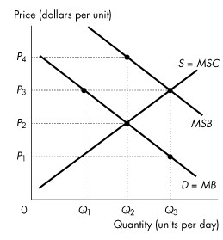
Figure 16.3.1

2) Refer to Figure 16.3.1. The figure shows the marginal private benefit curve, the marginal social benefit curve, and the market supply curve. If production is left to the private market, then the quantity produced is
A) zero.
B) Q1.
C) Q2.
D) Q3.
E) between 0 and Q1.
Answer: C
Diff: 1
Topic: Positive Externalities: Knowledge
3) Refer to Figure 16.3.1. The figure shows the marginal private benefit curve, the marginal social benefit curve, and the market supply curve. If production is left to the private market, then the price is
A) P1.
B) P3.
C) P2.
D) greater than P4.
E) P4.
Answer: C
Diff: 1
Topic: Positive Externalities: Knowledge

4) Refer to Figure 16.3.1. The figure shows the marginal private benefit curve, the marginal social benefit curve, and the market supply curve. If production is left to the private market, then at the equilibrium quantity the marginal social benefit from consumption is
A) less than the marginal cost to producers.
B) less than the marginal social cost of production.
C) equal to the marginal cost to producers.
D) equal to the marginal private benefit from consumption.
E) greater than the marginal cost to producers.
Answer: E
Diff: 2
Topic: Positive Externalities: Knowledge

5) Refer to Figure 16.3.1. The figure shows the marginal private benefit curve, the marginal social benefit curve, and the market supply curve. If production is left to the private market, then
A) the quantity produced is less than the efficient quantity.
B) the quantity produced is greater than the efficient quantity.
C) price is greater than marginal social benefit quantity.
D) the marginal cost curve is horizontal.
E) none of the above.
Answer: A
Diff: 2
Topic: Positive Externalities: Knowledge

6) Refer to Figure 16.3.1. The figure shows the marginal private benefit curve, the marginal social benefit curve, and the market supply curve. To promote an efficient quantity the government could grant a subsidy equal to
A) zero.
B) P1.
C) P3 - P1.
D) P4 - P1.
E) P2 - P1.
Answer: C
Diff: 2
Topic: Positive Externalities: Knowledge
7) Refer to Figure 16.3.1. The figure shows the marginal private benefit curve, the marginal social benefit curve, and the market supply curve. If a subsidy is granted that generates an efficient quantity, then quantity produced is
A) zero.
B) Q1.
C) Q2.
D) Q3.
E) greater than Q3.
Answer: D
Diff: 2
Topic: Positive Externalities: Knowledge

8) Refer to Figure 16.3.1. The figure shows the marginal private benefit curve, the marginal social benefit curve, and the market supply curve. If a voucher is given to consumers that generates an efficient outcome, then consumers pay
A) zero.
B) P1 per unit.
C) P2 per unit.
D) P3 per unit.
E) P4 per unit.
Answer: B
Diff: 3
Topic: Positive Externalities: Knowledge

9) Refer to Figure 16.3.1. The figure shows the marginal private benefit curve, the marginal social benefit curve, and the market supply curve. If a voucher is given to consumers that generates an efficient outcome, then producers receive a price of
A) zero.
B) P1 per unit.
C) P2 per unit.
D) P3 per unit.
E) P4 per unit.
Answer: D
Diff: 3
Topic: Positive Externalities: Knowledge
Use the table below to answer the following questions.

Table 16.3.1

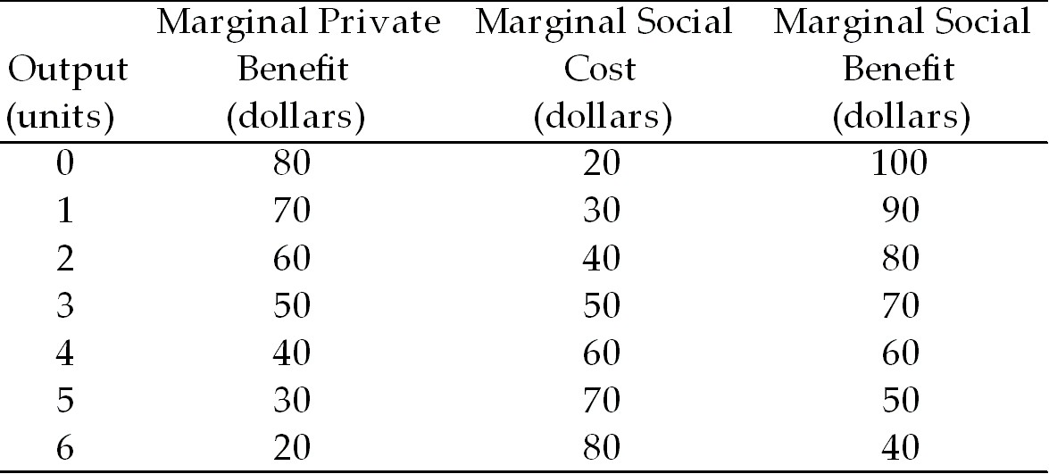

10) Refer to Table 16.3.1. The table shows marginal private benefit and the marginal social benefit from the consumption of chemical fertilizer and the marginal social cost of the production of fertilizer. Choose the correct statement.
A) The marginal external benefit is $20 per unit.
B) The marginal external cost is $10 per unit.
C) There are no externalities associated with this market.
D) The marginal external benefit is $10 per unit.
E) There is not enough information provided to determine whether or not there are externalities.
Answer: A
Diff: 2
Topic: Positive Externalities: Knowledge

11) Refer to Table 16.3.1. The table shows marginal private benefit and the marginal social benefit from the consumption of chemical fertilizer and the marginal social cost of the production of fertilizer. If production is left to the private market, the quantity produced is
A) 1 unit.
B) 2 units.
C) 3 units.
D) 4 units.
E) 5 units.
Answer: C
Diff: 2
Topic: Positive Externalities: Knowledge

12) Refer to Table 16.3.1. The table shows marginal private benefit and the marginal social benefit from the consumption of chemical fertilizer and the marginal social cost of the production of fertilizer. If production is left to the private market, the market price is
A) $70 a unit.
B) $60 a unit.
C) $50 a unit.
D) $40 a unit.
E) $30 a unit.
Answer: C
Diff: 2
Topic: Positive Externalities: Knowledge
13) Refer to Table 16.3.1. The table shows marginal private benefit and the marginal social benefit from the consumption of chemical fertilizer and the marginal social cost of the production of fertilizer. If production is left to the private market, then at the profit-maximizing output level marginal
A) social cost equals marginal private benefit.
B) private cost is less than marginal private benefit.
C) social cost is less than marginal private benefit.
D) social cost is greater than marginal private benefit.
E) social benefit is less than marginal private benefit.
Answer: A
Diff: 2
Topic: Positive Externalities: Knowledge

14) Refer to Table 16.3.1. The table shows marginal private benefit and the marginal social benefit from the consumption of chemical fertilizer and the marginal social cost of the production of fertilizer. If production is left to the private market, then
A) an efficient quantity is produced.
B) imposing a tax leads to production of the efficient quantity.
C) too much fertilizer is produced.
D) a system of marketable permits leads to production of the efficient quantity.
E) an inefficient quantity is produced.
Answer: E
Diff: 2
Topic: Positive Externalities: Knowledge

15) Refer to Table 16.3.1. The table shows marginal private benefit and the marginal social benefit from the consumption of chemical fertilizer and the marginal social cost of the production of fertilizer. An efficient quantity is produced if the government
A) subsidizes production by $20 per unit.
B) subsidizes production by $10 per unit.
C) provides vouchers for consumption of $20 per unit.
D) taxes production by $10 per unit.
E) either A or C.
Answer: E
Diff: 3
Topic: Positive Externalities: Knowledge
Use the figure below to answer the following questions.

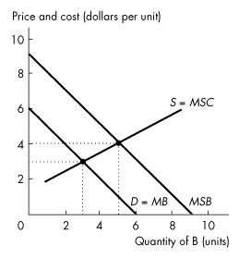
Figure 16.3.2

16) Refer to Figure 16.3.2. The figure shows the market for good B. How many units of good B are produced and consumed in an unregulated market?
A) 0 units
B) 3 units
C) 5 units
D) 6 units
E) 9 units
Answer: B
Diff: 1
Topic: Positive Externalities: Knowledge
Source: Study Guide

17) Refer to Figure 16.3.2.The figure shows the market for good B. What is the efficient quantity of good B?
A) 0 units
B) 3 units
C) 5 units
D) 6 units
E) 9 units
Answer: C
Diff: 2
Topic: Positive Externalities: Knowledge
Source: Study Guide
18) In Figure 16.3.2. The figure shows the market for good B. Which of the following government policies creates an efficient outcome?
A) Tax the production of B by $3 per unit.
B) Tax the production of B by $4 per unit.
C) Provide vouchers for consumption of B of $1 per unit.
D) Provide vouchers for consumption of B of $3 per unit.
E) Provide vouchers for consumption of B of $4 per unit.
Answer: D
Diff: 2
Topic: Positive Externalities: Knowledge
Source: Study Guide

19) Refer to Figure 16.3.2. The figure shows the market for good B. Under public provision, consumers pay ________ for each unit of B.
A) zero
B) $1
C) $2
D) $3
E) $4
Answer: B
Diff: 3
Topic: Positive Externalities: Knowledge

20) The devices the government can use to achieve a more efficient allocation of resources in the presence of external benefits include all of the following except
A) subsidies.
B) patents.
C) copyrights.
D) taxes.
E) vouchers.
Answer: D
Diff: 2
Topic: Positive Externalities: Knowledge

21) The devices the government can use to achieve a more efficient allocation of resources in the presence of external benefits include all of the following except
A) intellectual property rights.
B) subsidies.
C) public provision.
D) marketable permits.
E) patents.
Answer: D
Diff: 2
Topic: Positive Externalities: Knowledge
Source: Study Guide
22) Complete the following sentence. Knowledge
A) generates external benefits.
B) generates external costs.
C) displays diminishing marginal benefit.
D) is encouraged by intellectual property rights.
E) A and D are correct.
Answer: E
Diff: 2
Topic: Positive Externalities: Knowledge

23) Which of the following is least likely to display diminishing marginal benefit?
A) land
B) labour
C) capital
D) entrepreneurship
E) knowledge
Answer: E
Diff: 2
Topic: Positive Externalities: Knowledge

24) If positive externalities exist and production is left to the private market, then at the quantity produced
A) MSC = MSB.
B) MSC < MSB.
C) MSC > MSB.
D) MSB = marginal external benefit.
E) MSB = 1/MSC.
Answer: B
Diff: 2
Topic: Positive Externalities: Knowledge

25) Choose the incorrect statement.
A) A patent encourages invention.
B) A patent encourages innovation.
C) A patent has an economic cost.
D) A patent creates a negative externality.
E) A patent produces a monopoly.
Answer: D
Diff: 2
Topic: Positive Externalities: Knowledge

26) Three ways governments can encourage production of goods with external benefits are
A) private subsidies, marketable permits, and intellectual property rights.
B) private subsidies, marketable permits, and vouchers.
C) intellectual property rights, marketable permits, and vouchers.
D) taxes, emission charges, and marketable permits.
E) private subsidies, vouchers, and intellectual property rights.
Answer: E
Diff: 3
Topic: Positive Externalities: Knowledge
27) The economic benefit of a patent or copyright must be balanced against
A) the external benefit from the good.
B) the external cost of the good.
C) the marginal private cost of the good.
D) the cost of temporary monopoly.
E) the marginal social cost of the good.
Answer: D
Diff: 3
Topic: Positive Externalities: Knowledge

28) In recent years, as provincial governments attempt to balance their budgets, they have increased tuition fees considerably. This increase will likely result in
A) more students.
B) fewer students.
C) under-provision of education compared to the efficient level.
D) over-provision of education compared to the efficient level.
E) B and C.
Answer: E
Diff: 2
Topic: Positive Externalities: Knowledge

29) A patent is an example of
A) a subsidy.
B) a marketable permit.
C) a voucher.
D) a tax.
E) a legal device for creating property rights.
Answer: E
Diff: 1
Topic: Positive Externalities: Knowledge

30) To increase efficiency,
A) taxes are used to overcome both external benefits and external costs.
B) subsidies are used to overcome both external benefits and external costs.
C) subsidies are used to overcome external benefits, and taxes to overcome external costs.
D) taxes are used to overcome external benefits, and subsidies to overcome external costs.
E) emissions charges are used to overcome external benefits, and vouchers to overcome external costs.
Answer: C
Diff: 2
Topic: Positive Externalities: Knowledge
31) A market economy tends to ________ goods with negative externalities and ________ goods with positive externalities.
A) overproduce; overproduce
B) overproduce; underproduce
C) underproduce; overproduce
D) underproduce; underproduce
E) produce; consume
Answer: B
Diff: 2
Topic: Positive Externalities: Knowledge
Source: Study Guide

32) The outcome from a voucher scheme is efficient when the government makes the value of the voucher equal to
A) marginal external cost.
B) marginal external benefit.
C) private external cost.
D) private external benefit.
E) marginal social cost.
Answer: B
Topic: Positive Externalities: Knowledge
Skill: Conceptual
AACSB: Reflective Thinking

33) A voucher can eliminate the deadweight loss and lead to an efficient outcome if the value of the voucher equals the ________ of the good.
A) marginal external benefit
B) marginal social benefit
C) marginal private benefit
D) marginal social cost
E) marginal external cost
Answer: A
Topic: Positive Externalities: Knowledge
Skill: Conceptual
AACSB: Reflective Thinking
Use the figure below to answer the following questions.

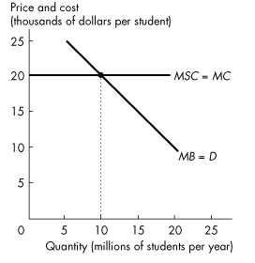
Figure 16.3.3

34) Refer to Figure 16.3.3. The figure shows the marginal private benefit and marginal social cost of a university education. If society's external benefit from university graduates is $10,000 each, then the
A) marginal social cost curve lies $10,000 to the left of the private marginal benefit curve.
B) marginal social cost curve lies $10,000 to the right of the private marginal benefit curve.
C) marginal social benefit curve lies $10,000 below the private marginal benefit curve.
D) marginal social benefit curve lies $10,000 above the private marginal benefit curve.
E) marginal social benefit curve is horizontal.
Answer: D
Topic: Positive Externalities: Knowledge
Skill: Analytical
AACSB: Analytical Skills

35) Refer to Figure 16.3.3. The figure shows the marginal private benefit and marginal social cost of a university education. Society's external benefit from university graduates is $10,000 each. With no subsidy
A) no students go to university.
B) less than 10 million students go to university.
C) 10 million students go to university.
D) more than 10 million students go to university.
E) none of the above.
Answer: C
Topic: Positive Externalities: Knowledge
Skill: Analytical
AACSB: Analytical Skills
36) Refer to Figure 16.3.3. The figure shows the marginal private benefit and marginal social cost of a university education. If society's external benefit from university graduates is $10,000 each, then
A) a subsidy of $10,000 per student paid to the universities achieves efficiency.
B) a tax of $10,000 per student imposed on the universities achieves efficiency.
C) 10 million students per year is the efficient number students.
D) a subsidy of $20,000 per student paid to the universities achieves efficiency.
E) none of the above answers are correct.
Answer: A
Topic: Positive Externalities: Knowledge
Skill: Analytical
AACSB: Analytical Skills

37) Refer to Figure 16.3.3. The figure shows the marginal private benefit and marginal social cost of a university education. A $10,000 subsidy to students results in a university charging tuition of
A) $0.
B) $10,000 per student.
C) $20,000 per student.
D) $30,000 per student.
E) $40,000 per student.
Answer: C
Topic: Positive Externalities: Knowledge
Skill: Analytical
AACSB: Analytical Skills

38) All of the following statements are correct except
A) knowledge about one process spills over into other segments of the economy.
B) additional knowledge makes people more productive, and there seems to be no tendency for the additional productivity from additional knowledge to diminish.
C) knowledge has no external benefit.
D) knowledge might be an exception to the principle of diminishing marginal benefit.
E) it is necessary to use public policies to ensure that those who develop new ideas have incentives to encourage an efficient level of effort.
Answer: C
Topic: Positive Externalities: Knowledge
Source: MyEconLab

39) Research and development ________ create an external benefit. With no intervention, we produce too ________ research and development.
A) does; little
B) does not; much
C) does not; little
D) does; much
E) none of the above. Research and development create an external cost.
Answer: A
Topic: Positive Externalities: Knowledge
Source: MyEconLab
40) Researchers produce the efficient quantity of research and development if they receive a voucher equal to the marginal ________ benefit, or a subsidy equal to the marginal ________ benefit.
Patents and copyrights ________ result in an efficient amount of research and development.
A) social; social; cannot
B) social; social; can
C) external; external; cannot
D) external; external; can
E) external; social; can
Answer: D
Topic: Positive Externalities: Knowledge
Source: MyEconLab

